

**King Abdulaziz University**

**Department of Computer Science**

**Faculty of Computing and Information Technology**

**CPCS-403, Term 2024**

**Website Description**

**For Final project**

Name : Mjjd Khalid Dirine

ID : 2137399

Contents

Project Idea (Problem Definition) : 3

Recommended Solution : 4

Benefits of the Provided Solution: 5

Storyboard for All Website Pages 7

• Home Page (index.php): 7

• Services Page (services.php): 8

• Shop Page (shop.php): 9

• Complaints Page (complaints.php**)**: 9

• Suggestions Page (suggestions.php): 10

• Contact Page (contact.html): 10

• Suggestions Page (video.php): 11

• login Page (login.php): 12

Site Map 12

Project Idea (Problem Definition) :

The goal of this project is to create a modern, user-friendly online platform for a clothing store that combines an intuitive user interface with robust backend functionality. With the increasing demand for online shopping, customers seek platforms that are easy to navigate, visually appealing, and responsive across all devices. Unfortunately, many online stores fail to provide a seamless shopping experience.

This project aims to address these challenges by developing a professional and well-structured website. Users can effortlessly browse products categorized into sportswear, winter clothing, and summer clothing.

In addition to the user interface, this project integrates a backend system powered by a database to enhance functionality. Customers can register accounts, log in securely, and have their data stored in the database.

By merging an attractive frontend with an efficient backend, the platform guarantees a modern shopping experience that meets the needs of customers and the store.

Recommended Solution :

The proposed solution is a clean, responsive, and dynamic website designed to serve as an online platform for the clothing store. The site will feature a main landing page showcasing the store's latest collections, deals, and promotions to attract customers.

To enhance customer engagement, the website will also provide a "Complaints and Suggestions" section, enabling users to share feedback, which will help improve customer relations and keep the store responsive to their needs.

The website's usability and aesthetic appeal remain a top priority, with a focus on intuitive navigation and visually appealing layouts. In addition to the user interface, the website is integrated with a robust backend system powered by a database. This backend functionality allows users to create accounts, log in securely, and have their data stored and managed efficiently.

This integration ensures seamless operations, improved data management, and a personalized shopping experience for users, making the platform a comprehensive and professional solution for the clothing store's online presence.

Benefits of the Provided Solution:

The solution provides a streamlined and user-friendly shopping experience through a clean, intuitive interface. Customers can easily navigate between pages, explore product categories, and access important information like store promotions.

The dedicated section for complaints and suggestions ensures that customer feedback is actively valued and addressed. This fosters trust and strengthens the relationship between the business and its clients.

With the integration of the backend and database, the website offers secure account management, allowing customers to register, log in.

The database integration ensures that the platform is scalable, ready to accommodate more products, users, and advanced features in the future.

By combining a professional interface with a powerful backend system, this solution ensures an engaging and efficient shopping experience while meeting the business’s operational needs.

Storyboard for All Website Pages

* Home Page (index.php):

On the homepage of our website, you can explore the categories of clothing available in our store, which are divided into three main sections: sportswear, winter clothing, and summer clothing. Additionally, you can easily navigate to other pages using the top navigation bar. At the bottom of the page, there is also a footer section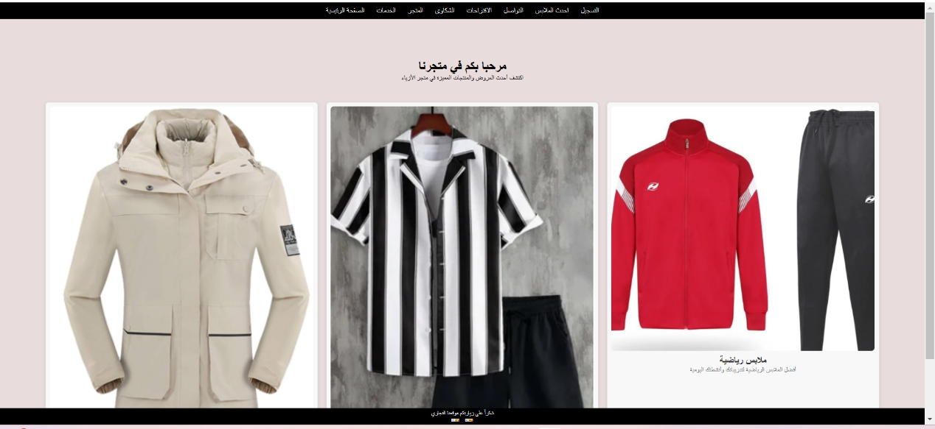

* Services Page (services.php):

On the services page, the table is displayed according to the method required from us. The table displays the type and description of each service, such as delivery within the city, which will be fast, and orders over 200 riyals will be delivered for free, and distinguished customers will have special discounts.

This page is for services.

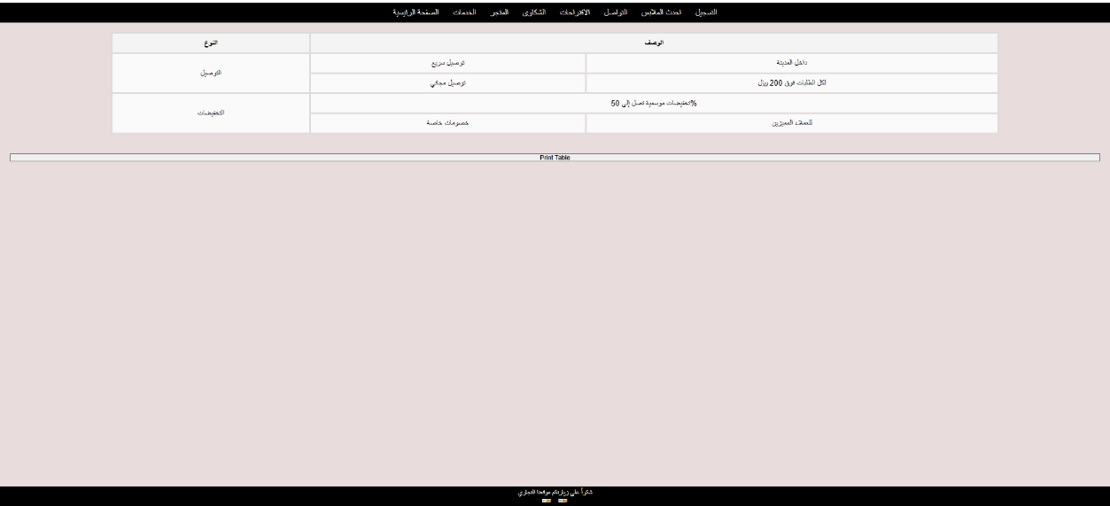

* Shop Page (shop.php):

Here on the shop page, the products available in our store will be displayed, and the images will be displayed according to the method required by us in the project.

* Complaints Page (complaints.php**)**:

Here, on the complaints page, users’ complaints will be taken through a form that is filled out by the user. The form meets all the requirements in the project, and it consists of entering five different data by the user.

* Suggestions Page (suggestions.php):

On the suggestions page, the user will enter his name and the suggestion that the user expects to be appropriate, such as what improvements should be taken into consideration to improve the site and other suggestions.

* Contact Page (contact.php):

Displays the company’s contact information along with an embedded form for users to submit inquiries or feedback.

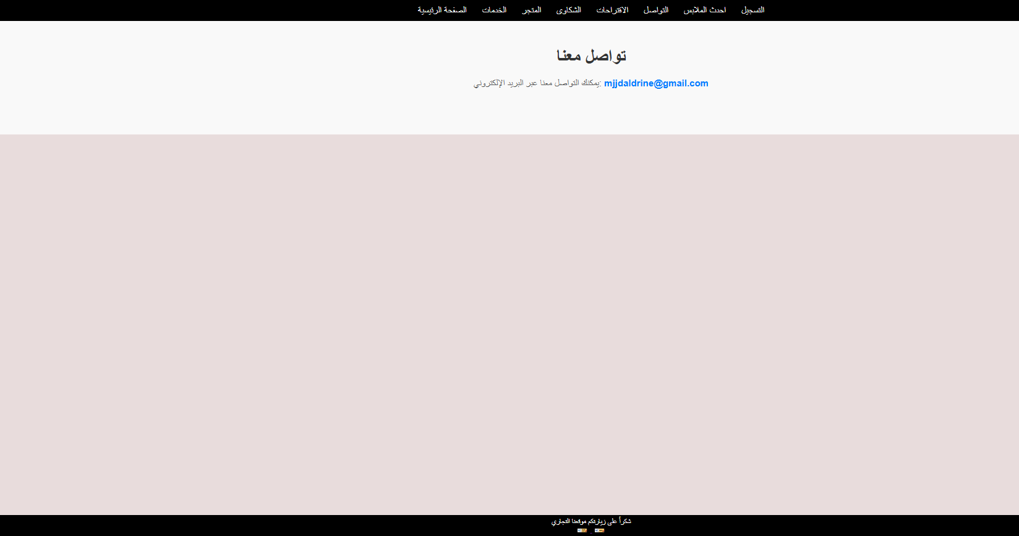

* Suggestions Page (video.php):

On the video page, the latest models or updates to the fashion of our site are displayed.

* login Page (login.php):

On the login page, the user will enter his email and the new password that suits him. If the email has been used before, the user will not be able to register with this email again. Also, the terms and conditions will be displayed as a PDF file according to what is required in the project.

Site Map

1. Home Page (index.php):

- Showcases categories of clothing available in the store, including sportswear, winter clothing, and summer clothing.

- Features a top navigation bar for seamless navigation between pages.

- Includes a footer section at the bottom of the page.

2. Services Page (services.php):

- Displays a table listing the type and description of each service, such as fast delivery, free delivery for orders over 200 riyals, and discounts for distinguished customers.

3. Shop Page (shop.php):

- Displays the store's available products, including images organized as per project requirements.

4. Complaints Page (complaints.php):

- Contains a form where users can submit complaints by filling in five required fields as per project specifications.

5. Suggestions Page (suggestions.php):

- Allows users to provide suggestions, such as site improvements or other recommendations, by entering their name and suggestion.

6. Contact Page (contact.php):

- Displays the company’s contact information.

7. Video Page (video.php):

- Showcases the latest models or fashion updates related to the site.

8. Login Page (login.php):

- Enables users to log in using their email and new password.

- Ensures that previously used emails cannot be reused for registration.

- Displays terms and conditions in a PDF format, as required in the project.